PRESS RELEASE
March 2018

P68 Pathfinder Automatic: for globetrotters and explorers
The timepiece that was built to make your dreams of adventure come true. 24/7. Under all possible weather conditions. At any time, day or night.
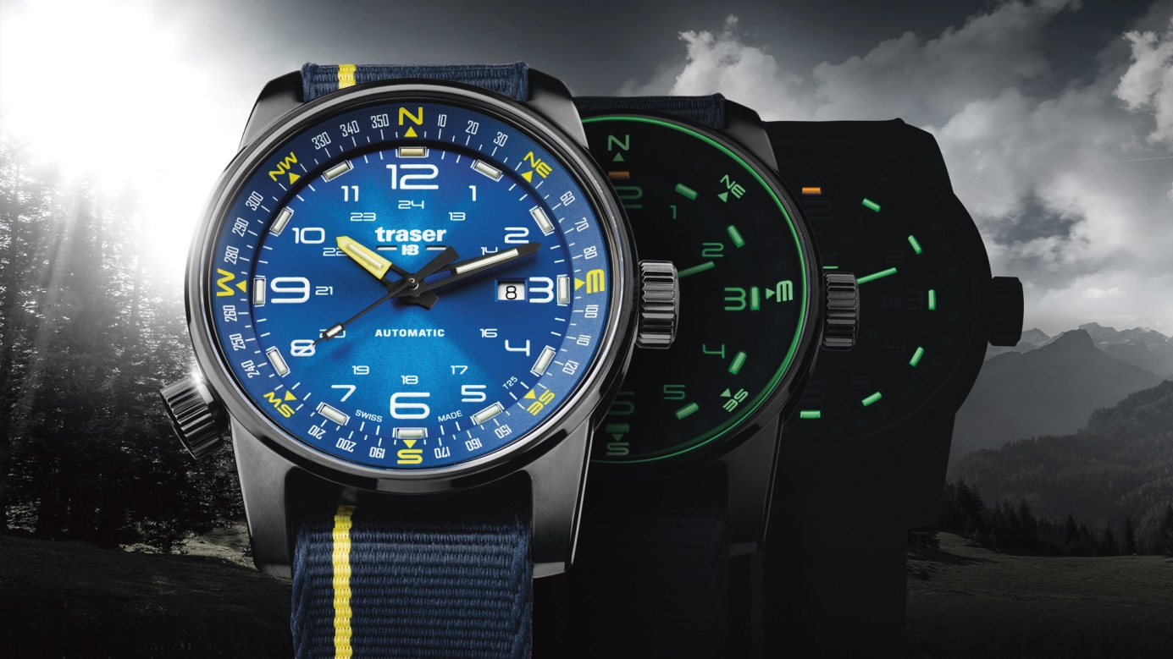
The P68 Pathfinder Automatic is dedicated to self-determined and self-confident individualists who transform their ordinary days into adventures. This collection captivates with clear lines. The purist case of blackened stainless steel is peppered with fine details: matt surfaces skilfully alternate with polished edges to add a touch of understated sophistication to the watch.

A glimpse inside the case reveals the secret of the P68 Pathfinder Automatic: a compass ring, which can be operated with one hand via the crown at “8 o’clock”. This ring, used in combination with the position of the sun and the hour hand, enables simple determination of the wearer’s current position and the cardinal directions.

Light is the primary element of the P68 Pathfinder Automatic and of all other traser models – traser, the inventor of the self-powered illumination technology trigalight®. Assuring perfect visibility, even in the most demanding environments, trigalight® functions without the need for external light or energy sources.

When night falls, a unique spectacle of light and colours begins on the time display. After the Super-LumiNova elements have faded, trigalight® takes over the leading role. The luminous pipes transform into the brightest stars on your wrist and continue to guide you reliably until dawn.
Technical Data - P68 Pathfinder Automatic - Swiss Made

Illumination: trigalight® self-powered technology for the hours indexes and hands
Super-LumiNova for the direction indicator on the compass ring, external numerals on the dial and luminescent glass seal

Movement: Swiss Made automatic movement, date window at “3 o’clock”

Power reserve: 38 hours

Size: Ø 46 mm

Glass: Anti-reflective sapphire

Case: Black PVD-coated stainless steel with matt polished details
Screw-down crown

Dial: Blue sun-brushed
Black sun-brushed

Compass ring: Integrated in the case. Operated via the crown at “8 o’clock”

Strap: Blue NATO strap with a thin gold-yellow line
Black NATO strap with a thin silver line

Water proof: 10 atm / 10 bar

Available: September 2017
RRP: CHF 895.00

References: 107719 P68 Pathfinder Automatic Blue
Black PVD-coated case, blue sun-brushed, blue NATO strap

107718 P68 Pathfinder Automatic Black
Black PVD-coated case, black sun-brushed, black NATO strap

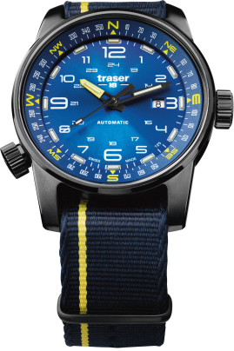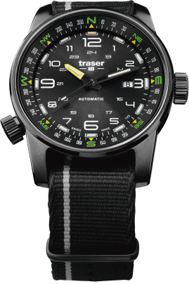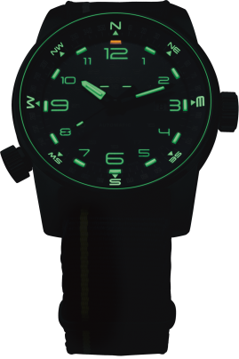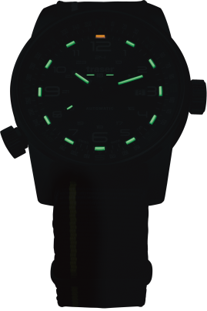

About traser swiss H3 watches and trigalight®

traser swiss H3 watches are manufactured under the SWISS MADE quality label at the brand’s headquarters in Niederwangen (near Bern, Switzerland). traser swiss H3 watches deliver unparalleled readability even in adverse light conditions thanks to the trigalight® self-powered illumination technology.

Invented by traser, trigalight® does not require any external energy source to deliver a virtually unchanged intensity of luminosity for at least 10 years.

Customers around the world (among whom active people, adventurers, keen sportspeople, nature lovers or professionals in tactical field and special units) trust the robust and functional traser swiss H3 watches.

Media contact:

Nina Zanetti-Martin

PR & Media Relations

E-mail: nina.zanetti@traser.com

Tel.: +41 79 305 51 59

