PRESS RELEASE
March 2018

GO VINTAGE – the new traser P67 Officer Pro Automatic series!
A trilogy in style: the perfect blend of an avant-garde retro note and a modern urban look.
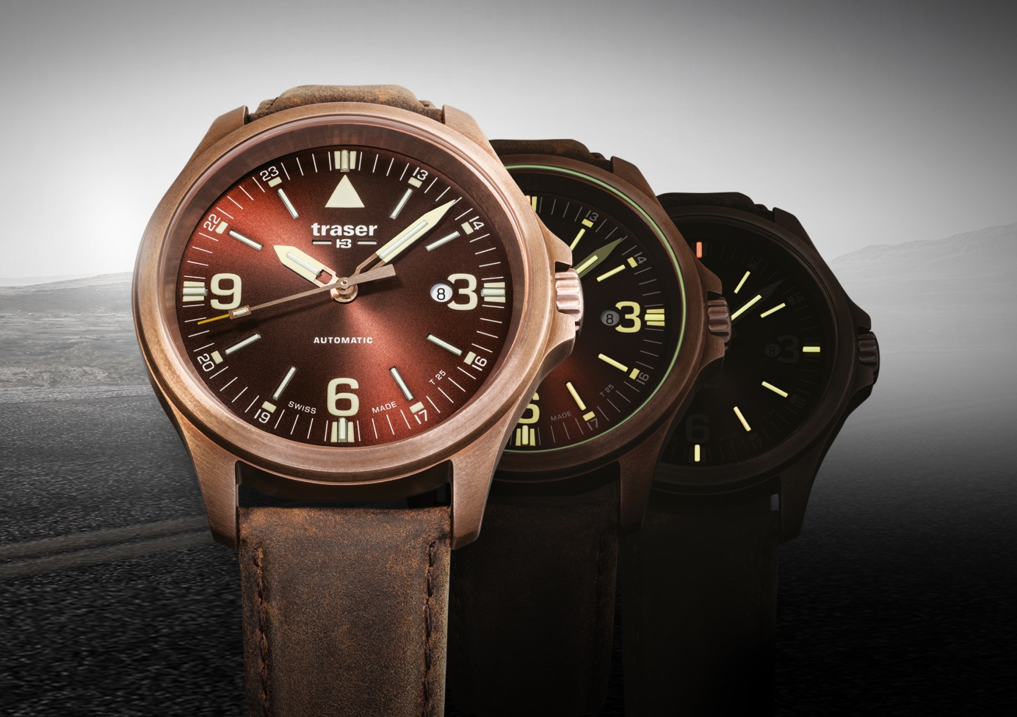
Inspired by history and intended for today’s individuals, the new P67 Officer Pro Automatic series perfectly enriches traser’s collection. Its tone is set by an elegant Swiss Made automatic movement, with a date window at “3 o’clock” and a power reserve of 38 hours, housed in a 45-mm-diameter case. The screwed see-through case back allows the wearer to cast an intimate eye into the watch’s heart, revealing the beauty of the complications.

By staying true to the unmistakable features of the acclaimed P67 Officer Pro family, this new model series once again surprises with a distinguished choice of materials. traser introduces three refined references: a version in an elegant brown or blue combined with a bronze case, and a version in a modern black with a PVD-coated case, which convey the most dapper looks. Contemporary styling with a slight retro touch blends with exquisite details and distinctive functionality.

The bronze case with vintage-like matte patina or the black case with PVD coating, coupled with a used-look leather strap, makes each timepiece unique. All of these elements combine to imbue the watch with a true sense of adventure: a hint of nostalgia for the great explorers of a time long past. This inspires the wearers to embark on a grand journey in their everyday lives.

In all its versions, the dial architecture of the P67 Officer Pro Automatic is equipped with trigalight® self-powered illumination technology, which guarantees optimal readability of the time, even in complete darkness. At dusk, for a fleeting moment, the trigalight® elements diffuse a glow to the time display, as though the watch was preparing for its night-time mission. The pure symmetry of the dial is rounded out by a Super-LumiNova print on the markers and a luminous glass seal.

The P67 Officer Pro Automatic has been revolutionised for an adventure of its very own. Here’s a vintage that comes with age and experience.

Technical Data – P67 Officer Pro Automatic – Swiss Made

Illumination: trigalight® self-powered technology on all hour indexes, on the hour and minute hands, and below the traser logo
Super-LumiNova on “3”, “6” and “9 o’clock” numerals as well as on all hour indexes
Luminous glass seal

Movement: Swiss Made automatic movement, date window at “3 o’clock“

Power reserve: 38 hours

Size: Ø 45 mm

Glass: Anti-reflective sapphire

Case: Vintage bronze (CuSn8 contains 92 percent copper and 8 percent tin)
Black PVD-coated stainless steel
See-through case back

Dial: Brown sun-brushed
Blue sun-brushed
Black matt

Strap: Genuine leather

Water Resistance: 10 atm / 10 bar

Available: Mid May 2018

RRP: From CHF 695.00

References: 108073 P67 Officer Pro Automatic Bronze Brown
Vintage bronze case, brown dial, brown genuine leather strap

108074 P67 Officer Pro Automatic Bronze Blue
Vintage bronze case, blue dial, blue genuine leather strap

108075 P67 Officer Pro Automatic Black
Black PVD-coated case, black dial, black genuine leather strap

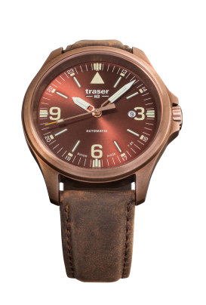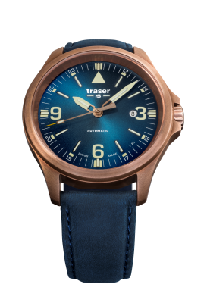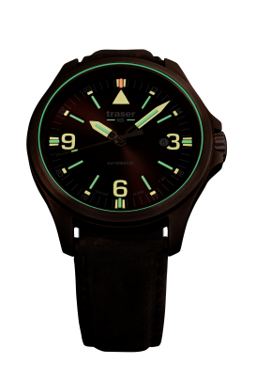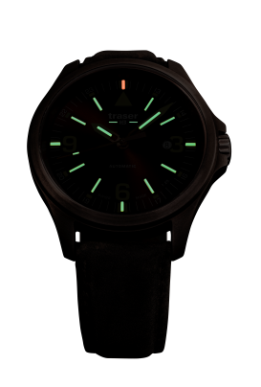
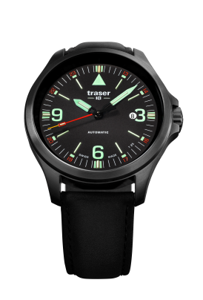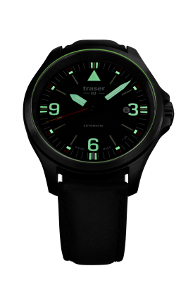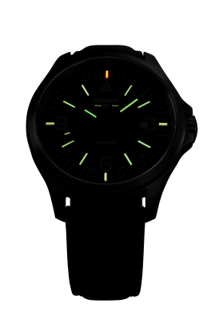

About traser swiss H3 watches and trigalight®

traser swiss H3 watches are manufactured under the SWISS MADE quality label at the brand’s headquarters in Niederwangen (near Bern, Switzerland). traser swiss H3 watches deliver unparalleled readability even in adverse light conditions thanks to the trigalight® self-powered illumination technology.

Invented by traser, trigalight® does not require any external energy source to deliver a virtually unchanged intensity of luminosity for at least 10 years.

Customers around the world (among whom active people, adventurers, keen sportspeople, nature lovers or professionals in tactical field and special units) trust the robust and functional traser swiss H3 watches.

Media contact:

Nina Zanetti-Martin

PR & Media Relations

E-mail: nina.zanetti@traser.com

Tel.: +41 79 305 51 59

