PRESS RELEASE
March 2018

A timepiece of understated elegance: the new traser P59 Essential!
For minimalists and individuals who aim to experience real freedom. The P59 Essential is predestined to reliably accompany its wearers through daily adventures and unexpected discoveries.

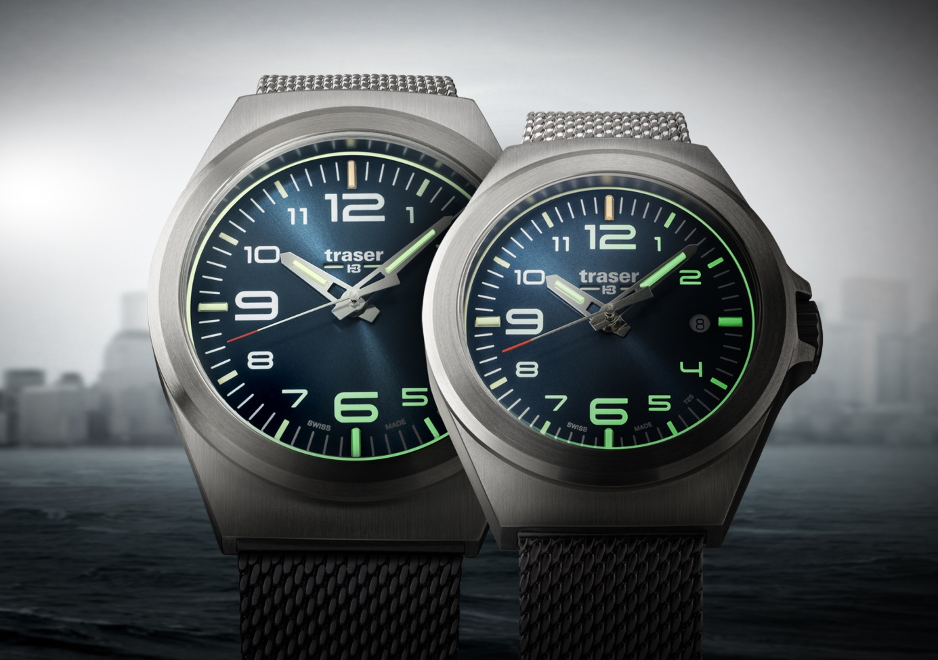
The new P59 Essential is a breath of fresh air, maritime air, for traser’s collection. The case design is evocative of a submarine porthole and as such, its role is to allow the best visibility of the clear numerals. These watches are traser’s entry-level range, equipped with the essential amount of trigalight® elements.
This collection of five models (which are available in two sizes, Ø 37 mm and Ø 42 mm) presents all the key features that make a traser watch unique: functionality, design aesthetic and excellent readability of the time. The in-house manufactured self-powered illumination technology trigalight® is conveniently positioned at ’’12”, ’’3”, ’’6” and ’’9 o’clock”, as well as on the hour and minute hands. Complemented by the luminescent material Super-LumiNova, this watch becomes a spotlight on the open sea.

The P59 Essential is defined by its purist design. This classic three-hander with a Swiss quartz movement is housed in a robust case of either silver brushed or black PVD-coated stainless steel. A deep sun-brushed blue or a matt black coloured dial convey a strong seaside feel. Reduced to the maximum and thus evoking more with less, this watch is constituted by all substantial elements.

Suitable for every occasion, this stylish timepiece becomes a contemporary travel companion for all your journeys. The Milanese bracelet, a highly sought-after trend, offers a comfortable alternative to the classic stainless steel bracelet. The P59 Essential models are also available with a robust NATO or high-quality genuine leather strap.

Technical Data – P59 Essential – Swiss Made

Illumination: trigalight® self-powered illumination technology at ’’12”, ’’3”, ’’6” and ’’9 o’clock”, as well as on the hour and minute hands and below the traser logo
Super-LumiNova for all hour numerals and indexes at ’’1”, ’’2”, ’’4”, ’’5”, ’’7”, ’’8”, ’’10” and ’’11 o’clock”
Luminescent print around the dial

Movement: Swiss Made quartz movement, date window at ‘’3 o’clock”

Sizes: S Ø 37 mm, M Ø 42 mm

Glass: Anti-reflective sapphire

Case: Stainless steel
Black PVD-coated stainless steel

Dial: Blue sun-brushed
Black matt

Bracelet / Strap: Milanese stainless steel & Milanese black PVD-coated stainless steel
Genuine leather
NATO

Water Resistance: 10 ATM / 10 bar

Available: April 2018
RRP: From CHF 195.00

References:
Ø 37 mm versions
108203 P59 Essential S Blue
Stainless steel case, blue dial, Milanese stainless steel bracelet
108208 P59 Essential S Blue
Stainless steel case, blue dial, blue genuine leather strap
108210 P59 Essential S Blue
Stainless steel case, blue dial, blue NATO strap
108204 P59 Essential S Black
PVD-coated stainless steel case, black dial, Milanese black PVD-coated stainless steel bracelet
108212 P59 Essential S Black
PVD-coated stainless steel case, black dial, black NATO strap
Ø 42 mm versions
108205 P59 Essential M Blue
Stainless steel case, blue dial, Milanese stainless steel bracelet
108214 P59 Essential M Blue
Stainless steel case, blue dial, blue genuine leather strap
108216 P59 Essential M Blue
Stainless steel case, blue dial, blue NATO strap
108206 P59 Essential M Black
PVD-coated stainless steel case, black dial, Milanese black PVD-coated stainless steel bracelet
108218 P59 Essential M Black
PVD-coated stainless steel case, black dial, black NATO strap

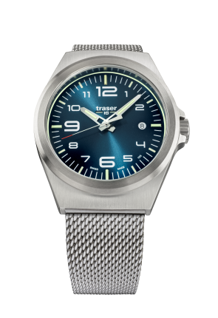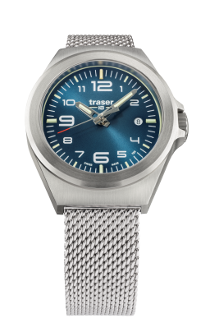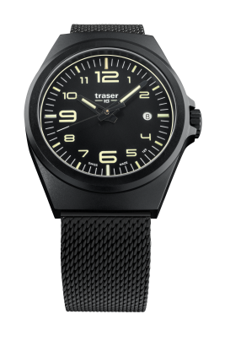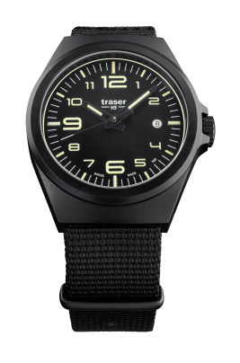
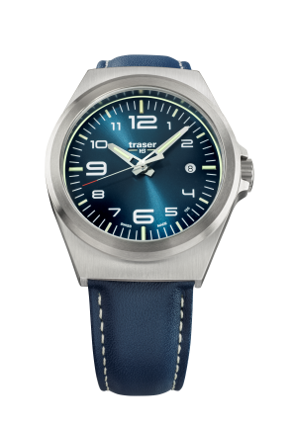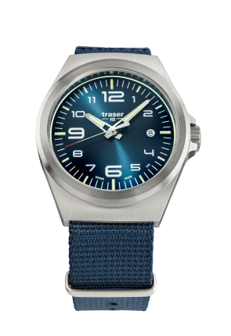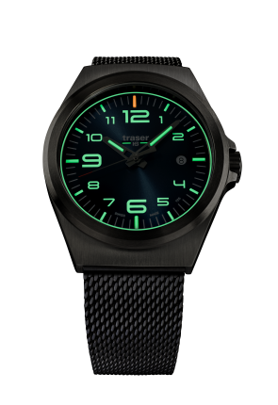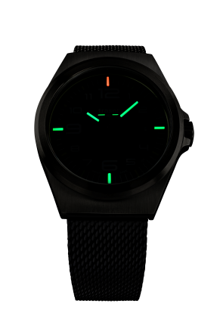

About traser swiss H3 watches and trigalight® self-powered illumination technology

traser swiss H3 watches are manufactured under the SWISS MADE quality label at the brand’s headquarters in Niederwangen (near Bern, Switzerland). traser swiss H3 watches deliver unparalleled readability even in adverse light conditions thanks to the trigalight® self-powered illumination technology.

Invented by traser, trigalight® does not require any external energy source to deliver a virtually unchanged intensity of luminosity for at least 10 years.

Customers around the world (among whom active people, adventurers, keen sportspeople, nature lovers or professionals in tactical field and special units) trust the robust and functional traser swiss H3 watches.

Media contact:

Nina Zanetti-Martin

PR & Media Relations

E-mail: nina.zanetti@traser.com

Tel.: +41 79 305 51 59

